|  |  |  |  |  |  |  |
| --- | --- | --- | --- | --- | --- | --- |
| VILNIAUS KOLEGIJA  UNIVERSITY OF APPLIED SCIENCES  FACULTY OF ELECTRONICS AND INFORMATICS  Image result for viko logo | | |  | | | VILNIUS COLLEGE  Image result for viko logoFACULTY OF ELECTRONICS AND INFORMATICS |
|  | | |  | | |  |
| **COMPUTERS & NETWORKS** | | |  | | | **INTRODUCTION TO INFORMATICS** |
| PRACTICAL ASSIGNMENT  INVESTIGATION OF RS-232 COMMUNICATION INTERFACE  6531BX028 PI18E | | |  | | | PRACTICAL ASSIGNMENT  SPOTIFY USER MANUAL  6531BX028 PI18E |
| STUDENT | DŽIUGAS PEČIULEVIČIUS | STUDENT | | DŽIUGAS PEČIULEVIČIUS |
| (SIGNATURE)  5/21/2020 | | |  | | | LECTURER |
| LECTURER | MARTYNAS ŠAPUROV | (SIGNATURE)  10/17/2018 | | VIRGILIJUS KUKLIERIUS |
| (SIGNATURE)  5/21/2020 | | |  | | | 2018 |

2020

**TABLE OF CONTENTS**

OBJECTIVE 4

WHAT IS RS-232? 5

BD9 CONNECTOR 6

DTE AND DCE COMMUNICATIONS 8

ABOUT THE PROTOCOL 10

ADVANTAGES OF RS-232 SERIAL COMMUNICATION PROTOCOL 12

DISADVANTAGES OF RS-232 SERIAL COMMUNICATION PROTOCOL 12

GOOD TO KNOW 13

GENERAL CONCLUSIONS 14

# OBJECTIVE

Our objective is to investigate and understand how DB-9 Serial communication (also known as RS-232) interface works.

# WHAT IS RS-232?

It is a form of serial data transmission, or in other words it’s a form of communication. Most people call it a serial connection. At one time it was the most used form of data transmission. Despite the “RS” standing for “Recommended Standard”, the specifications of RS-232 are relatively flexible and have been repeatedly updated over the past several decades. DB-9 cable was used for RS-232 transmissions.

RS-232 communicates data one bit at a time, unlike a parallel interface that sends multiple bits simultaneously. The key benefit of this is that serial communication is less complicated and requires fewer wires.

Historically, the RS-232 Serial Communication Protocol was commonly used for personal computing devices such as printers, projectors, modems, point of sale devices, and more. Today, many of these applications have switched to USB or wireless connections. However, RS-232 is still used heavily in automation, servers, networking, industrial communications, and many other applications.

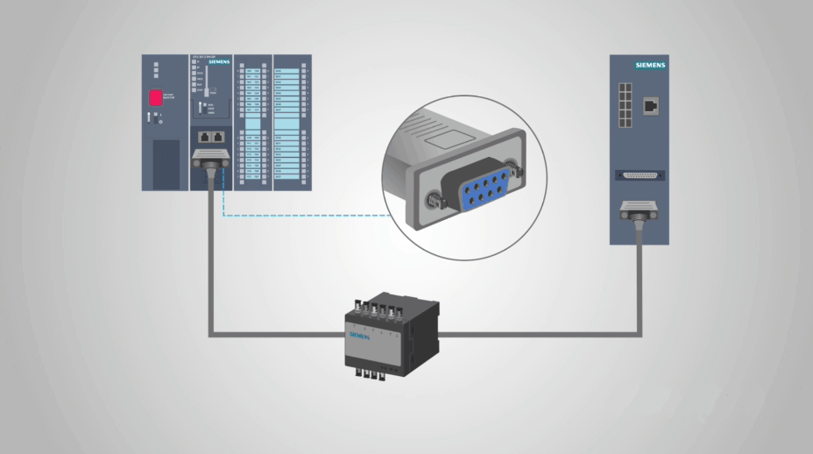

Figure 1- 9 pin DB-9 cable RS-232

# BD9 CONNECTOR

There are two connector sizes used for RS-232: DB9 and DB25. In both cases, RS-232 connects a Data Terminal Equipment end (DTE, the transmitter) to a Data Communication Equipment end (DCE, the receiver), which is discussed later in the report.

The 9 pin connector seems to be a little more common these days. The table below shows the description and abbreviation for each pin. The column labeled “I/O” specifies the data direction from the male connector.

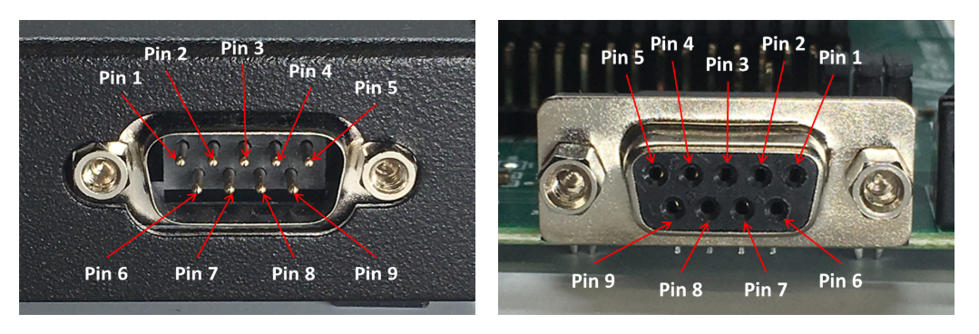

Figure 2 - Male and Female DB9 connectors

|  |  |  |  |  |
| --- | --- | --- | --- | --- |
| **Number** | **Name** | **Abbreviation** | **I/O** | **Description** |
| Pin 1 | Data Carrier Detect | DCD | Input | The DCE is connected to the line |
| Pin 2 | Receive Data | RXD | Input | This transmits data from the DCE end to the DTE end |
| Pin 3 | Transmit Data | TXD | Output | This transmits data from the DTE end to the DCE end |
| Pin 4 | Data Terminal Equipment Ready | DTR | Output | The DTE end is ready for transmission |
| Pin 5 | Signal Ground | GND |  | The carries the ground signal |
| Pin 6 | Data Communication Equipment Ready | DSR | Input | The DCE end is ready for transmission |
| Pin 7 | Request To Send | RTS | Output | The DTE end requests the DCE to prepare for transmission |
| Pin 8 | Clear To Send | CTS | Input | The DCE end gives the DTE the go-ahead |
| Pin 9 | Rind Indicator | RI | Input | This transmits an incoming ring signal to the DCE |

In DTE / DCE communication, RTS (Request to Send) is an output on the DTE and input on the DCE. CTS (Clear to Send) is the answering signal coming from the DCE. Before sending a data, the DTE asks permission by setting its RTS output to high. No data will be sent until the DCE grants permission by using the CTS line. The DTE uses the DTR (Data Terminal Ready) signal to indicate it is ready to accept information, whereas the DCE uses the DSR signal for the same purpose. DTR/DSR are normally ON or OFF for the whole connection session (e.g. Off-hook), while RTS/CTS are ON or OFF for each data transmission. DCD (Data Carrier Ready) is used by the modem when a connection has been established with remote equipment, while RI (Ring Indicator) is used by the modem to indicate a ring signal from telephone line.

# DTE AND DCE COMMUNICATIONS

There are two different types of RS-232 devices. DTE and DCE. DTE stands for Data Terminal Equipment. It’s a common example of this is a computer. DCE stands for Data Communications Equipment. And a common example for this would be a modem.

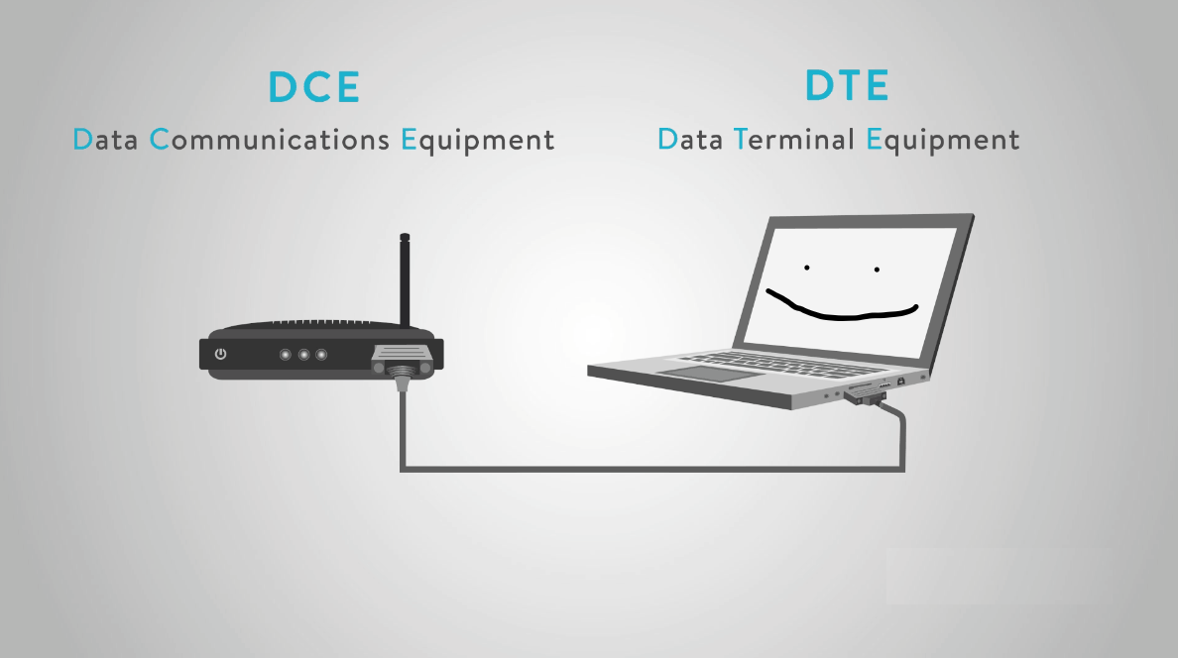

Figure 3 - RS-232 device types

The reason this is important is because two DTE or two DCE devices cannot talk to each other without some help. This is typically done by using a reverse (null-model) cable to connect devices.

Typically, PLCs (Programmable Logic Computers) will be DTE and our devices used will be DCE and everything should talk to each other.

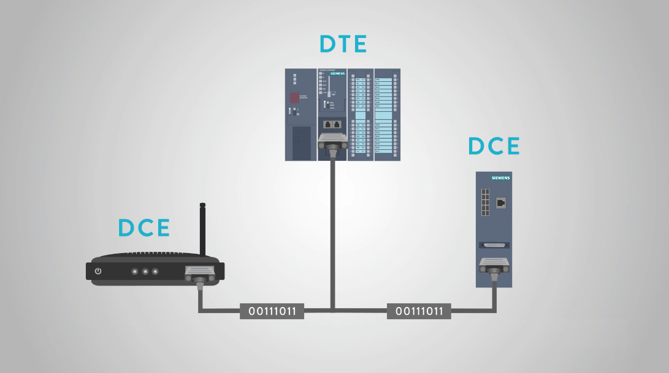

Figure 4 - PLC network

A very common example is that many people are probably familiar with is a computer connected to a printer. While USB has become the standard, RS-232 is still widely used for older printers in the workplace.

The RS-232 protocol and cable allow the computer to give commands to the printer via a voltage signal which are 0 and 1’s. The printer deciphers those commands and completes the print.



Figure 5 - RS-232 connected to a printer

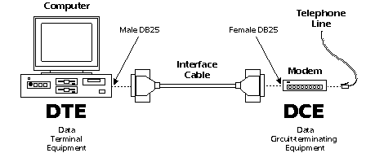

# ABOUT THE PROTOCOL

A protocol is on or a few sets of hardware and software rules agreed to by all communication parties for exchanging data correctly and efficiently.

**Synchronous and Asynchronous Communications**

Synchronous Communication requires the sender and receiver to share the same clock. The sender provides a timing signal to the receiver so that the receiver knows when to “read” the data. Synchronous Communication generally has a higher data rates and greater error-checking capability. A printer is a form of Synchronous Communications.

Asynchronous Communication has no timing signal or clock. Instead, it inserts Start / Stop bits into each byte of data to “synchronize” the communication. As it uses less wires for communication (no clock signals), Asynchronous Communication is simpler and more cost-effective. **RS-232 is the form of Asynchronous Communication.**

**Drilling Down: Bits and Bytes**

Internal computer communications consists of digital electronics, represented by only two conditions: ON or OFF. We represent these with two numbers: 0 and 1, which in the binary system is termed a Bit.

A Byte consists of 8 bits, which represents decimal number 0 to 255, or Hexadecimal (HEX) number 0 to FF. As described above, a byte is the basic unit of Asynchronous communications.

**Baud rate, Data bits, Parity, and Stop bit**

Data Bits in a Communication Packet

The baud rate is the communication speed that measures the number of bit transfers per second. For example, 19200 baud is 19200 bits per second.

Data bits are a measurement of the actual data bits in a communication packet. For example, the above graphic shows eight (8) data bits in a communication packet. A communication packet refers to a single byte transfer, including Start / Stop bits, Data bits and Parity. If you are transferring a standard ASCII code (0 to 127), 7 data bits are enough. If it is an extended ASCII code (128 to 255), then 8 data bits are required.

Parity is a simple way to error-check. There are Even, Odd, Mark and Space indicators. You can also use no parity. For Even and Odd parity, the serial port sets the parity bit (the last bit after the data bit) to a value to ensure that the data packet has an Even or Odd number of logic-high bits. For example, if the data is 10010010, for Even parity, the serial port sets the parity bit as 1 to keep the number of logic-high bits Even. For Odd parity, the parity bit is 0 so that the number of logic-high bits is Odd. Mark parity simply sets the parity bit to logic-high and Space sets the parity bit to logic-low, so that the receiving party can determine if the data is corrupted.

Stop bits are used to signal the end of a communication packet. This also helps to synchronize different clocks on the serial devices.

# ADVANTAGES OF RS-232 SERIAL COMMUNICATION PROTOCOL

RS-232 is remarkable for its simplicity and low cost. It is used by many legacy devices and is favorable in many point-to-point applications when no further complexity is needed such as in industrial control equipment.

Unlike USB, the most common modern alternative, maximum RS-232 cable lengths are dependent upon capacitance. However, a standard rule of thumb is that cables of us to 15 meters are generally supported, while USB can support 3 to 5 meters. RS-232 also handles noise better than many other protocols.

Finally, converters such as RS-232 to Ethernet are relatively low cost compared to similar equipment for other protocols. This makes RS-232 relatively adaptable.

# DISADVANTAGES OF RS-232 SERIAL COMMUNICATION PROTOCOL

The RS-232 protocol isn’t perfect. For starters, it has a slower baud rate, especially over long distances, and needs to use higher voltages. More significantly for everyday use, it is just less practical to set up than USB, especially for casual computer users.

From a more technical perspective, the protocol is only appropriate for system-to-system communications in the single-master-single-slave configuration. Any communication with multiple chips or sensors on one end or with a more complex configuration will not be supported by RS-232.

The speed at which data can be transferred. Data can be transferred at around 20 kilobytes per second (20 KB/s). Which is pretty slow compared to what people are used to nowadays. Another issued with RS-232 is that the maximum length a cable is about 15 meters. Wire resistance and voltage drops become an issue with cables longer than this. This is one reason RS-232 is not used much as newer technology for remote installations.

# GOOD TO KNOW

* **Data Frame:** A data frame is a transmission of data that begins with a start bit and ends with a stop bit. This is necessary because of the asynchronous nature of RS-232 serial communication. Because Data transmission can start at any moment, the receiver needs some way of knowing when a transmission starts and when it ends. The data frame defines this explicitly.
* **Start Bit:** The start bit is identified by the space-line level (a 0 in binary). The line is in mark state (a 1 in binary) when idle. Therefore, the start bit is easy to identify.
* **Data Bits:** Data bits are pretty straightforward. They are the bits of data of the actual communication along RS-232.
* **Parity Bits:** An additional bit can be added to a data word for error-detection purposes. The receiver can compare the parity bit value against the calculated value of the data.
* **Stop Bits:** The sop bit isn’t an actual bit per se, but a minimum period of idle time following transmission. When that minimum idle time can be paired with a start bit, the receiver knows it has received a full data frame.
* **Baud Rate:** Baud rate is the data transmission speed of a serial line. Both the transmitter and the receiver must be on the same baud rate. It is measured in bit per second.
* **Full-Duplex vs. Half-Duplex:** Serial interfaces like RS-232 can be either full-duplex or half-duplex. In full-duplex setups, bot devices can transmit data simultaneously, while half-duplex, they must take turns.

# GENERAL CONCLUSIONS

For years, RS232 has been a standard in industry. Today, USB and Ethernet have started to phase out this older serial communication standard.

However, with the help of simple adapters, devices can still talk to each other using the new and old standards.

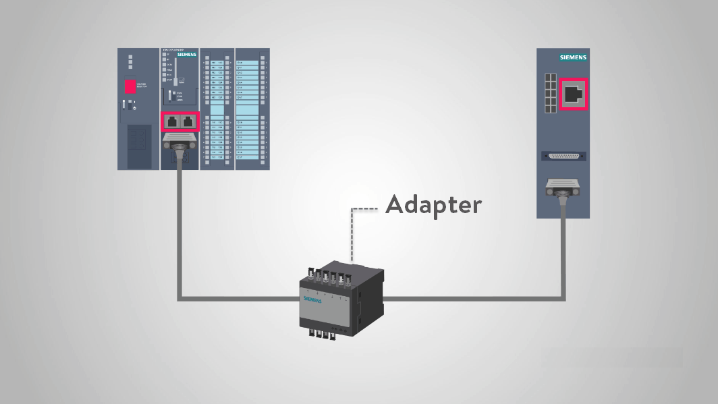

There are still many manufacturers using RS232 since it has always been widespread and inexpensive.

Manufacturers may use RS232 to connect PLCs to devices like HMIs, input and output modules, and motor drives, just to name a few.

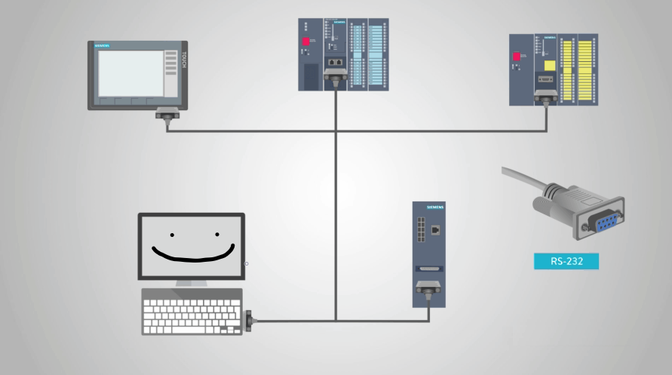

Keeping in mind that RS232 is simply a form of serial communications, or a way to transmit data. A standard DB9 cable is probably the most used cable for this application.